[name of dealership]

Prevention and Response Plan
PLAN OVERVIEW
The information contained in this Dealership COVID-19 Prevention and Response Plan represents the Dealership’s plan to prevent and respond to the COVID-19 pandemic based on Guidance from the California Department of Public Health and the California Division of Occupational Safety and Health, including the Emergency Temporary Standards that took effect on November 30, 2020.
While the pandemic has continued for some months by now, the full impact of COVID-19 on the health of Californians is not yet fully known. Reported illness ranges from very mild (some people have no symptoms) to severe illness that may result in death. Certain groups, including people aged 65 or older and those with serious underlying medical conditions, such as heart or lung disease or diabetes, are at higher risk of hospitalization and serious complications. And while transmission is most likely when people are in close contact with an infected person showing symptoms, public health officials caution that risk of transmission is significant even from persons who do not show any symptoms or have not yet developed symptoms.
Precise information about the number and rates of COVID-19 by industry or occupational groups, including among critical infrastructure workers, is not available at this time. There have been multiple outbreaks in a range of workplaces, including Dealerships, indicating that workers are at risk of acquiring or transmitting COVID-19 infection.
It remains essential that we all take every possible step to ensure the safety of our employees and the public. Key prevention practices include:
- Physical distancing to the maximum extent possible (minimum of 6 feet);
- Use of face coverings by employees (where respiratory protection is not required) and customers/clients;
- Frequent handwashing and regular cleaning and disinfection;
- Self-administered symptom checks on a daily basis; and
- Training all of our employees on these and other elements of our COVID-19 Dealership Prevention and Response Plan.
In addition, this Plan outlines our processes to identify new cases of illness in the dealership and, when they identified, a plan to intervene quickly and work with public health authorities to halt the spread of the virus. Our Plan will change from time to time as new guidance is received from government officials and health care professionals.
PURPOSE OF PLAN
This Plan provides processes and practices to support a safe, clean environment for our employees, customers and vendors. The guidance is not intended to be exhaustive, as it does not include all county health orders, nor is it a substitute for any existing safety and health-related regulatory requirements such as those of Cal/OSHA.
Stay current on changes to public health guidance and state/local orders, as the COVID-19 situation continues. Cal/OSHA has more safety and health guidance on their Cal/OSHA Guidance on Requirements to Protect Workers from Coronavirus webpage. CDC has additional guidance for businesses and employers. While this Plan addresses many important issues, no one can anticipate every possible future scenario. It’s intended to provide you with processes, practices and guidelines.
Please use common sense in avoiding contact with others in the workplace where possible and in preventing the spread of COVID-19.
The Dealership maintains an open-door policy and we invite any questions, inquiries or concerns so we can openly discuss and address them. Employees (and their authorized representatives, if any) are encouraged to report to the Dealership—without risk of reprisal—any symptoms of COVID-19, possible COVID-19 exposures, and possible COVID-19 hazards in the workplace. We welcome input from all personnel as we continue to navigate the dynamic public health information and regulatory requirements.
This Plan sets forth practical recommendations and guidelines including:
- Guidelines for setting up a COVID-19 response team;
- Personal hygiene in the workplace;
- Personal Protection Equipment (PPE), safety protocols and suggestions for the workplace;
- Cleaning and disinfection procedures;
- Social distancing strategies; and
- Protocols for isolating employees who become ill at work.
COVID–19 TEAM AND TEAM CAPTAIN
The dealership has established a COVID-19 Prevention and Response Team led by the Dealership’s COVID–19 Team Captain. The Team Captain and the Team are to carry out the procedures and practices of this Plan to provide for the well-being of our employees, customers and vendors.
We encourage all employees to identify and, where possible, direct any COVID-related concerns to the assigned Response Team members. This will increase our ability to address and incorporate new information as it arises. That said, employees should not hesitate to raise information or other concerns to other Response Team Members or any management employee of the Dealership if the identified official is not available.
Team Captain
Has overall responsibility to oversee the Dealership’s Prevention and Response Plan, which includes:
Social Distancing Protocol
Ensure that social distancing guidelines for employees and customers are adhered to.
Sanitization & Disinfection
Ensure that daily and periodic disinfection, including routine and deep cleaning procedures are performed at the dealership.
Communication & Training
Works to manage all related communications, training and response to any COVID-19 situation.
Protective Equipment and Supplies
Secures all necessary equipment and supplies to protect employees and customers.

Here is our COVID–19 Team Leadership, whom you should contact with questions or concerns:

Team Captain — GM
Sanitation/Disinfection
Protective Equipment and Supplies
Notifications/Communications
Human Resources

HEALTH AUTHORITY CONTACT INFORMATION

[INSERT CONTACT INFORMATION FOR STATE, COUNTY, AND LOCAL HEALTH AUTHORITIES]
REQUIRED PROTECTIVE EQUIPMENT AND SUPPLIES CHECKLIST
Masks
- As a general rule, all persons in the workplace wear a face covering that is clean and undamaged, and that complies with guidance from public health officials, including the CDC. This means a face covering of tightly-woven or non-woven material with no visible holes or openings and that covers the nose and mouth.
- Masks or face coverings must be worn at all times when indoors and when outdoors and less than six feet away from another person.
- This may be a washable cloth item covering the nose and mouth or a disposable mask. Employees may provide their own complaint masks if they wish, but the Dealership will make masks available for those who wish to use them.
- Customers and Vendors are included in the mask mandate.
- There are limited exceptions to the mask requirements, including primarily exceptions driven by medical or mental health conditions or other limitations, such as hearing impairments. If any employee believes that an exception may apply, he or she is directed to contact the Response Team Captain for further discussion.
- Other forms of face coverings (e.g., clear plastic face shields) are not interchangeable with masks as described here, but they may be utilized as an alternative where mask requirements are subject to exceptions. For example, hearing-impaired personnel or those communicating with them may be instructed to wear clear face shields with a drape at the bottom.
- Face covering requirements may vary widely from time to time and from jurisdiction to jurisdiction.
Gloves
- Touch flex/ Surgical Nitrile Gloves will be made available as needed to augment other transmission prevention protocols, such as where distancing and other protocols may be considered insufficient or impractical.
- Employees with questions or issues relating to Gloves or other PPE should contact the Team Captain.
Infrared Thermometer
- Available for no-touch verification of temperature of employees and vendors to check for temperature above 100.3
Hand Sanitizer
- Sanitizer with minimum 60% ethyl alcohol or 70% isopropyl alcohol
Hand Soap
- Antibacterial Soap should be located in all hand-washing areas
Disinfectant Solution
- EPA approved Disinfectant should be used in all work areas
Wipes / Disposable Towels
- In all work areas and public areas

TRAVEL RESTRICTIONS AND
NOTIFICATION REQUIREMENTS
Limit all business travel only to essential business requirements. Essential travel does not include manufacturer product launches, factory/industry meetings, or meetings that could be conducted by phone/conference.
Consult with your manager if you are unsure about the criticality of any upcoming travel.
We recognize that personnel may engage in essential or non-essential travel during their time away from work. We encourage all employees to follow all applicable recommendations from local, state, and national officials regarding travel while the coronavirus remains widespread. These may include, but are not necessarily limited to:
  - The CDC recommends that staying home is the best way to protect yourself and others from COVID-19, and urges those considering travel to consider not only themselves but others with whom they may come into contact
  - The California Department of Public Health has advised all persons to avoid non-essential travel and strongly recommends that anyone traveling into California (including returning residents) should self-quarantine for 14 days after arrival to limit the spread.
  - Some county health departments (such as Santa Clara County) have issued mandatory directives requiring those entering or returning to the county from travel of more than 150 miles to quarantine for 14 days upon arrival.
For those employees who do choose to travel, we require that each informs the Dealership’s Team Captain regarding any interstate or interregional travel, including travel on a cruise ship. We may require a 14 day self-quarantine before returning to work for such travel.
Travel advisories are updated regularly, and employees and Response Team Members should watch for regular updates and plan to respond accordingly.
PREVENTION OF INFECTION
The following procedures and equipment should be used to protect you, fellow employees, vendors, and customers that enter our dealership:
Wash Hands with Soap and Water Wash your hands frequently with soap and warm water, scrubbing with the soap for 20 seconds
- Before, during, and after preparing food
- Before eating food
- Before and after caring for someone who is sick with vomiting or diarrhea
- Before and after treating a cut or wound after using the toilet
- After changing diapers, or cleaning up a child who has used the bathroom
- After touching an animal, animal food, or animal waste
- After handling pet food or pet treats
- After touching garbage, blowing your nose and/or sneezing or coughing
- If your hands are visibly dirty or greasy
Face Covering/Mask
- Face coverings or masks must be available and worn in the dealership at all times when others are present or in public areas
- The Dealership will provide and refresh (clean or replace) masks for personnel
- Must be worn by employees
- Customers without masks must be asked if they would like one provided by the dealership. Customers who fail or refuse to follow face covering requirements should be brought to the attention of the General Manager.
PREVENTION OF INFECTION
Gloves
- Gloves are provided to anyone who desires to wear them
Guidance on Wearing Disposable Gloves
DO Change gloves when heavily soiled or torn | DON’T touch surfaces such as door handles, keyboards, etc., with contaminated gloves
DO Dispose of used gloves appropriately in an approved receptacle | DON’T touch your face or adjust masks or gloves with contaminated gloves
DO wash hand thoroughly before and after glove use | DON’T remove one glove and then pull the other glove off by the fingertips
 | DON’T reuse disposable gloves once they have been removed
Using Hand Sanitizer
- If soap and water are not readily available, use an alcohol-based hand sanitizer that contains at least 60% alcohol, and wash with soap and water as soon as you can.
- Put enough sanitizer on your hands to cover all surfaces
- Rub your hands together until they feel dry. This should take around 20 seconds
- Do not rinse or wipe off the hand sanitizer before it is dry; it may not work well against germs.

IDENTIFICATION OF HAZARDS
The Dealership encourages all personnel—employees and any on-site vendors or others—to participate in the identification and evaluation of potential COVID-19 hazards. All personnel should be familiar with their surroundings and be attentive to possible weak links in our approach.
Anyone who become aware of a condition they believe may be a COVID-19 hazard is both encouraged and required to bring it to the attention of the Response Team Captain or other Response Team Member or Dealership manager.
SOCIAL AND PHYSICAL DISTANCING
Employees must follow the Dealership’s Social Distancing Protocol.
Consistent with federal, State, and local guidance, we are taking steps to reduce the number of persons in any area(s) at any one time, including visitors. We are also regularly reviewing options to reduce or eliminate the need for workers to be in the workplace, including concepts such as remote work arrangements and staggering shift times.
State/Local Social Distancing Protocol shall be posted at each entrance to the dealership.
Social Distancing Means:
- Stay at least six feet apart from co-workers and customers whenever feasible
- Follow guidelines on occupancy limitations that have been modified in response to COVID-19; these changes may change regularly, and all employees are encouraged to be aware of updates
- Use digital platforms when available
- Avoid congregating with co-workers
Social Distancing with Customers:
- Do not use handshakes or similar greetings
- Encourage customer appointments and have customers practice physical distancing while waiting for service
- Limit passengers in the vehicle during test drives to only a single customer with the employee sitting in opposite back seat, when applicable. Both customer and employees are strongly encouraged to wear face coverings
Physical distancing is an important measure for stopping the spread of COVID-19 both at work and off work time
SOCIAL AND PHYSICAL DISTANCING
Social Distancing Includes Physical Distancing
Why do we practice physical distancing as part of our Social Distancing Protocol?
Health officials believe that COVID-19 spreads among people who are in close contact (within about 6 feet) for an extended period. This spreading of infection occurs when an infected person coughs, sneezes, or talks, and droplets from their mouth or nose are launched into the air and land in the eyes, mouths or noses of people in close proximity with one another. The droplets can also be inhaled into the lungs.
Recent studies indicate that people who are infected but do not have symptoms likely also play a role in the spread of COVID-19. as well as children who may not show any symptoms.
It is believed that people may also contract COVID-19 by touching a surface or object that has the virus on it and then touching their own mouth, nose, or eyes. However, this is not thought to be the main way the virus spreads. COVID-19 can live for hours or days on a surface, depending on factors such as sun light and humidity.
Physical distancing helps limit contact with infected people and contaminated surfaces.
Although the risk of severe illness may be different for everyone, anyone can get and spread COVID-19. Everyone has a role to play in slowing the spread and protecting themselves, their family, and their community.
Structural Measures to Reduce Contact with Others
Measures can include:
Physical partitions or visual cues (e.g., floor markings, colored tape, or signs to indicate where workers and/or customers should stand).
Install barriers to protect employees and customers where feasible. For example: plastic curtains between service bays that are side-by-side and plastic screens between cashiers and customers
Where barriers are not feasible, employees are required to wear face coverings. (Some jurisdictions require face coverings outside the home.)
Adjust meetings to ensure physical distance and use smaller individual meetings at facilities
Close or restrict common areas where personnel are like to congregate
Redesign office spaces, cubicles, etc. to ensure workspaces allow for 6 ft. between employees
Provide a single, clearly designated entrance and separate exit to help maintain physical distancing, wherever possible
Place additional limitation on the number of workers in enclosed areas to ensure at least 6 feet of separation
Stagger employee breaks to maintain physical distancing
Adjust maximum occupancy rules based on the size of your facility (capacity limits should be low enough to ensure physical distancing, but in no case more than 50% maximum occupancy
Physical Distancing with Customers
We must provide curbside delivery or pick up where possible
We should perform sales and agreements while with physical distancing and structural distancing in place, including the use of remote/digital platforms as feasible (such as online sales)
We have discontinued shuttle services
Food and Beverages
Food such as cookies, donuts, muffins, bagels, etc., may not be served in the dealership. Indeed, mandatory restrictions expressly ban the sale of food and beverages for in-store consumption, and the Dealership will not provide such sundries, even free of charge.
CLEANING AND DISINFECTING PROTOCOLS
Thoroughly clean high traffic areas such as showrooms, waiting areas, break rooms, and areas of ingress and egress including stairways and elevator controls
Frequently disinfect commonly used surfaces, including:
- Counters
- Credit card machines
- Touchscreens
- Doorknobs
- Armrests
- Toilets
- Handwashing facilities
- Door handles
- Vehicle keys
- Vehicles displayed in the showroom (door handles, seat adjustment controls, radio, etc.)
- Customer Vehicles In Service – When Customer Drops Off and Before Returning to Customer
Clean touchable surfaces between shifts or between users, whichever is more frequent
This includes, but is not limited to:
- Work surfaces
- Keys
- Stationary and mobile equipment controls
Avoid sharing phones, tablets, office equipment, or tools wherever possible. Never share PPE.
Equip terminals, desks, and help counters with proper sanitization products, including hand sanitizer and sanitizing wipes, and provide personal hand sanitizers to all staff directly assisting customers.
- Time clocks
- Payment portals
- Pens and styluses
CLEANING AND DISINFECTING PROTOCOLS
Cleaning Vehicles
Dedicate employees to sanitize vehicles when:
- Dropping off vehicles for service/repairs
- Picking up vehicles after service/repairs
- Returning from rental of vehicle
- Before and after test drives
Use protective barriers such as disposable mats and seat covers when applicable, such as during test drives and moving returned vehicles.
Standard cleaning and disinfection should focus on frequently touched surfaces, or “hot spots,” including
- the steering wheel;
- door handles;
- gear shifter;
- cup holders;
- seat buckles;
- buttons or touch screens;
- wiper and turn signal stalks;
- passenger and driver door armrests;
- grab handles; and
- seat adjusters.
Cleaning and Disinfecting Work Together
According to the CDC, cleaning is using soap (or detergent) and water to remove germs from a surface. It doesn’t necessarily kill the germs but reduces the number of germs and thus the chance of spreading infection.
Disinfecting, on the other hand, uses chemicals to kill the germs on a surface after cleaning further lowering the risk.
Sanitizing lowers the number of germs to a safe level and works by either cleaning or disinfecting.
For Enhanced Cleaning of hard surfaces, the CDC recommends cleaning dirty surfaces or objects with soap and water first, and then using a disinfectant. Be sure to read the directions on the label, as many products advise keeping the surface wet for a time and ensuring adequate ventilation during use.
For soft surfaces such as carpeted floors or draperies, use an EPA-registered household disinfectant or clean the surface with soap and water (or appropriate cleaners) and launder items that can be washed using the warmest recommended setting and dry thoroughly.
Using disposable gloves and a face covering, sanitize and disinfect all areas where you perform your daily work:
- Tools and toolbox
- Workstations, computers, screens/monitors, counters, etc.
- Locker/Storage area
- Common surface areas including windows, doors, and light switches
- Computer screens, keyboards and related equipment
All areas of the dealership must be sanitized and disinfected with special to the following items by dealership assignees:
- Restrooms
- Customer seating areas
- Lunchrooms
- Doors and door knobs

CLEANING AND DISINFECTING PROTOCOLS
The Dealership will arrange for the following cleaning and disinfecting:
Daily Clean:
- Baseline scope of typical housekeeping duties. Primarily cleaning/wiping of surfaces with limited use of disinfectants (usually in bathrooms).
Enhanced Clean
- Use of CDC/EPA-approved disinfectant cleaners on “high touch” surfaces in common areas/public spaces at regular frequency such as railings, doors, door knobs and handles, desktops, chairs/seating areas, customer waiting/reception areas, light switches; bathrooms including toilets, faucets and sinks; breakrooms and breakroom equipment like refrigerator handles, microwaves, tables.
Deep Clean
- In addition to the “Enhanced Clean” scope above, “deep cleaning” applies to disinfecting items such as desks, chairs, computers and related equipment, phones, printers, fax machines, office door handles/knobs, cafeterias, etc.
Deep Clean Per Health Department Recommendations
- Disinfection/sanitation requirements set forth by the state or local health department. In instances where an employee, vendor or customer has been identified as having COVID-19 symptoms or a positive test, please contact your state or local health department for appropriate disinfection/sanitation instructions.

Make sure all the following areas are cleaned, disinfected and sanitized regularly:
Lobbies/Entrances/Conference Centers/High Traffic Public Use Areas:
- Entrances and interior door handles/push plates
- Reception desks/counters, Lobby/common area furniture (chair arms/table surfaces), Stairwell railings
- Water fountains
Customer Waiting Areas/Lounges
- Chairs, tables (jackets, purses and/or briefcases should only be placed on the floor)
- Discard all books, magazines
- Children’s play area
- TV Remote Control
Restrooms
- Door handles/push plates, light switches, counters, faucets, flush valve/handles, toilet stall door locks, partition handles and railings, Toilets and urinals, Toilet paper/paper towel dispensers
Breakrooms
- Door handles/push plates, counter surfaces, furniture/table surfaces/chairs, refrigerator/microwave/coffee pot handles, vending machines (if applicable), ice/water machines (if applicable)
SERVICE DEPARTMENT
Advise customers that there will not be any courtesy shuttle service and consider assisting with ride-share to return customer after dropping off vehicle for service.
Do not allow congregating in customer waiting lounge.
Try to get electronic signatures where possible from customer (email, etc.).
Checklist
- Inform customers before they come to dealership about the dealership’s COVID-19 procedures.
- Inform customers how we disinfect their vehicles.
- Disinfect/Sanitize the vehicle before and after service
- Observe 6-foot social distancing between customers and service advisor
- Use photo-estimating as much as possible to contact customer outlining needed repairs.
- When all work is complete, the vehicle should be disinfected again.
- Minimize touch points such as tablets, pens, credit cards and keys.
- Complete payments electronically
- Do not reuse pens until they can be disinfected
- Sanitize hand, scan tools, shared or any special tools
- Deep clean and disinfect loaner/rental vehicles.+
PARTS DEPARTMENT
Checklist
- Observe 6-foot social distancing between customers and parts counterperson – tape off distance area on ground or by other means of demonstrating distancing.
- Minimize physical contact with customers (e.g., use tablets, pens, credit cards, parts scanners, keyboards).
- Sanitize and disinfect work areas often– e.g., after every customer at front counter or tech at back counter.
- Enable online ordering with online payment and notification of curbside pickup.
- Offer contactless delivery services for local area.
- Designate a shelf or bin for each technician to expedite storage of needed parts and eliminate social contact.
DISINFECTION AUDIT CHECKLIST
The COVID-19 team must verify that necessary items are being done using an audit list or form. HR Hotlink contains the Audit Tool to create the daily audit.
At the very least, the team must confirm that:
Was there a deep cleaning for all common surfaces?
Was there a deep clean in all offices, desk and conference rooms (cabinets, desk, table and chair surfaces)?
Was there a deep clean of all fixtures/equipment/tools often used or touched (doors, windows, handles, faucets, sinks, bathrooms, point of sale, telephones, etc.)?
Was there a deep clean of the break rooms/lounge (tables, chair surfaces, dispensers, vending machines, etc.)?
Did all employees do a self-check of symptoms prior to starting work?
IDENTIFICATION AND RESPONSE TO EXPOSURES
The Dealership is committed to identifying and responding promptly to any COVID-19 cases in the workplace or other potential exposures. It is important that all employees share this commitment in theory and in practice, and the Dealership encourages and requires all personnel to act accordingly.
KNOW THE SYMPTOMS
COVID-19 Symptoms generally appear 2–14 days after exposure to the virus, although there may be instances of longer or shorter periods.
People with COVID-19 have had a wide range of symptoms reported – ranging from mild symptoms to severe illness
Symptoms identified by the CDC include:
- Fever or chills
- Cough
- Shortness of breath or difficulty breathing
- Fatigue
- Muscle or body aches
- Headache
- New loss of taste or smell
- Sore throat
- Congestion or runny nose
- Nausea or vomiting
- Diarrhea
This list does not include all possible symptoms. The CDC will continue to update the list as more information becomes available.

Older adults and people who have severe underlying medical conditions like heart or lung disease or diabetes seem to be at higher risk for developing more serious complications from COVID-19 illness.
ON-SITE SCREENINGS
Provide self-temperature and/or self-symptom screenings for all workers at the beginning of their shift and any personnel entering the facility
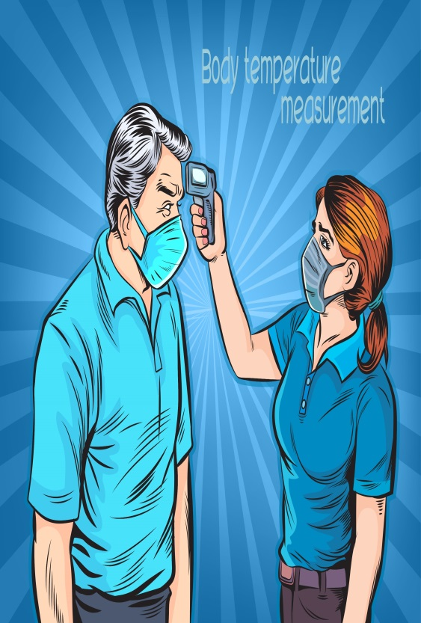
- If someone conducts the screening, make sure the temperature/symptom screener avoids close contact with workers to the extent possible.
- Both screeners and employees should wear face coverings for the screening.

STAY HOME IF SICK
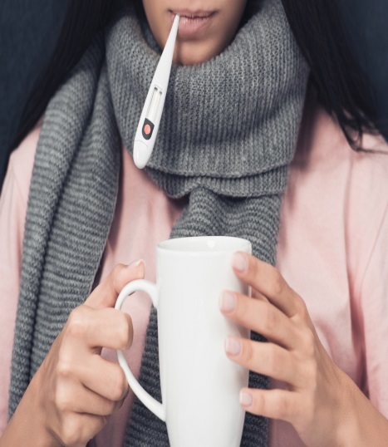
Encourage employees to stay home, call a healthcare provider if they have symptoms.
Employees should NOT come into work if the employee is experiencing
- Fever or chills
- Cough
- Shortness of breath or difficulty breathing
- Fatigue
- Muscle or body aches
- Headache
- New loss of taste or smell
- Sore throat
- Congestion or runny nose
- Nausea or vomiting
- Diarrhea
Or if they or someone they live with have been diagnosed with COVID-19.
WHEN TO SEEK MEDICAL ATTENTION
Seek medical attention if symptoms become severe, including persistent pain or pressure in the chest, confusion, or bluish lips or face.
This list is not all possible symptoms. Please call your medical provider for any other symptoms that are severe or concerning to you.

Call 911 if you have a medical emergency
Notify the operator that you have, or think you might have, COVID-19. If possible, put on a cloth face covering before medical help arrives.
SYMPTOMATIC EMPLOYEES OR CUSTOMERS
If an employee or customer is (or becomes) symptomatic of COVID-19, it is important that they be sent home immediately.
Symptomatic employees should be asked to return home and self-quarantine until they no longer pose a significant risk of virus transmission, which has been delineated as at least 10 days after COVID-19 symptoms first appeared, or longer, if required, to ensure that the employee has been without a fever (without the assistance of fever-reducing medication) for at least 24 hours and other COVID-19 symptoms have improved.
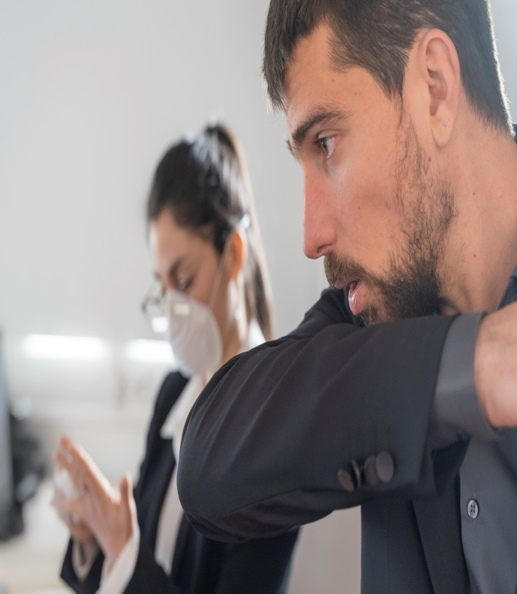
Area(s) where employee worked (e.g., service department) will be closed for deep cleaning and sanitization process will be performed upon confirmation that a person who had COVID-19 symptoms or was infected with COVID-19 was present at the dealership.
INVESTIGATION OF EXPOSURES
COVID-19 exposures are defined by Cal-OSHA regulations as a “close contact” exposure to COVID-19 case, which includes being within six feet of an individual with COVID-19 for a cumulative total of 15 minutes or more during any 24-hour period within or overlapping with the “high-risk exposure period” for that individual. The High-Risk Exposure Period for a person who develops COVID-19 symptoms is the period beginning two days before first developing symptoms and continuing until ten days after symptoms have passed, provided there have been at least 24 hours without fever (without medication) and other symptoms have improved. For those not showing symptoms, the High-Risk Exposure Period is from two days before until ten days after the sample was collected for their first positive COVID-19 test.
COVID-19 Exposures are evaluated without regard to the use of face coverings by either individual involved in a potential exposure.
Identifying the COVID-19 Exposure and the High-Risk Exposure Period
In the event of a COVID-19 Exposure, the Dealership will attempt to determine the date and time that the COVID-19 Case was in the workplace and when any exposures may have taken place.
The Dealership will, where possible, identify the time periods during which the COVID-19 Exposure may have happened, including when the affected individuals were in the workplace, as well as their activities and all locations within the workplace which may have been visited by he COVID-19 Case during the High-Risk Exposure Period. This will require the Dealership to determine the parameters of the High-Risk Exposure Period for the affected individual.
Determining who may have been affected by a potential Exposure
In investigating the timing and location of potential COVID-19 Exposures, the Dealership will seek to identify any individual(s) who may have come into Close Contact with the COVID-19 Case during the High-Risk Exposure Period. This will generally include discussions with affected individuals and those identified as potentially affected.

EXCLUSION OF THOSE AFFECTED
BY A COVID-19 EXPOSURE
Individuals identified as having had a COVID-19 Exposure must be excluded from the workplace until the Return-to-Work requirements under state and local regulations are met. This generally requires exclusion from the workplace for at least 10 days after the last-known COVID-19 exposure took place.
This includes both COVID-19 exposures in the workplace or outside the workplace, even those unrelated to work.
For example, if an employee reports a COVID-19 exposure in the home (e.g., contact with a family member who tests positive for COVID-19), the employee must be excluded from the workplace.
Exclusion must continue for 10 days from the last-known exposure. This may require exclusion for more than 10 days where exposure continues. For example, if an individual continues to have close contact with a COVID-19-infected family member despite because isolation is not possible, the exclusion period begins immediately upon initial exposure and continues until 10 days after the last exposure during the affected individual’s High-Risk Exposure Period (e.g., 10 days after symptoms appeared in the family member).
Watch out for Potentially Confusing Changing Information
Because of the wide variety of federal, State, and local government and health department officials involved in overseeing COVID-related restrictions in many aspects of pandemic life, and because of the ongoing scientific evaluation of an increasing array of data regarding the virus and its behavior, changes to existing exclusion recommendations and requirements are made periodically. And not always at the same pace by each stake-holding regulator. Because of this, the Dealership works hard to ensure that its COVID-19 response operates under the most recent applicable standards, which may not be the most recent limits publicized in new media sources.
If you hear of modified standards you think may be applicable, contact the COVID Response Team Leader for Clarification
Duration of quarantine for exposed individuals is a good example. Under the Cal/OSHA ETS that was approved on November 30, 2020, exclusion of exposed individuals is 14 days from the last-known COVID-19 exposure. Guidance from the CDC, however, allowed for certain exclusions of 10 days post-exposure, albeit with additional post-exclusion requirements for monitoring and PPE. The California Department of Public Health adopted the CDC standard, and an Executive Order from the Governor modified the 14-day period to conform with that of the California Department of Public Health (to 10 days), but this Executive Order also requires exclusion quarantines to continue longer if local public health officials require a longer period, as some still do.
If you have questions regarding changing standards, they can be directed to the Response Team Leader for more clarity.
RECORDKEEPING AND ACCESS
It is our policy to:
Report information about COVID-19 cases at our workplace to the local health department whenever required by law, and provide any related information requested by the local health department.
Report immediately to Cal/OSHA any COVID-19-related serious illnesses or death, as defined under CCR Title 8 section 330(h), of an employee occurring in our place of employment or in connection with any employment.
Maintain records of the steps taken to implement our written COVID-19 Prevention Program in accordance with CCR Title 8 section 3203(b).
Make our written COVID-19 Prevention Program available at the workplace to employees, authorized employee representatives, and to representatives of Cal/OSHA immediately upon request.
Keep a record of and track all COVID-19 cases. The information will be made available to employees, authorized employee representatives, or as otherwise required by law, with personal identifying information removed.
RETURNING TO WORK
Employees should contact Human Resources prior to returning to work to advise that they have met the Return-to-Work Criteria and to discuss documentation that may be required prior to return to company premises.
People with COVID-19 symptoms who have suspected COVID-19 or who have tested positive with COVID-19 can return to work, after confirmation from Human Resources.
Persons with COVID-19 who have symptoms and were directed to care for themselves at home may discontinue isolation and return to work when they have met the following criteria:
- Improvement in respiratory symptoms (e.g., cough, shortness of breath), and
- The later of the following:
- At least 10 days have passed since symptoms first appeared; and,
- At least 24 hours have passed since recovery defined as resolution of fever without the use of fever-reducing medications.
Note that recommendations for discontinuing isolation differ between persons who have had symptoms and persons who have not had symptoms of COVID-19

RETURNING TO WORK
People without COVID-19 symptoms but who have tested positive for COVID-19 can return to work, after confirmation from Human Resources.
Persons who have tested positive COVID-19 and who have never had symptoms may return to work when 10 days have passed since the date of their first positive COVID-19 diagnostic test (sampling date, not results date) assuming they have not subsequently developed symptoms since their positive test. If they develop symptoms, then the symptom-based strategy should be used. Note, because symptoms cannot be used to gauge where these individuals are in the course of their illness, it is possible that the duration of viral shedding could be longer or shorter than 10 days after their first positive test.
If you have any symptoms of COVID-19 notify the COVID-19 Team Captain immediately and contact a health care professional for advice.
If any employee has symptoms, disinfecting of work areas should occur immediately.
OUR PLAN SUMMARY
Management and/or a designated member of the company COVID-19 Team is tasked with ensuring that our dealership takes appropriate measures to meet city, state, and federal guidelines
What the Company must do:
- Follow the written plan
- Provide contact info COVID-19 Team and for local health department
- Train and communicate with all current employees and new hires prior to working
- Regularly audit for compliance and correct deficiencies
- Investigate any COVID-19 illness and update plan as needed
- Identify close contacts of an infected employee and isolate
- Adhere to guidelines of company-provided training
ACKNOWLEDGMENT OF RECEIPT OF PLAN AND AGREEMENT TO COMPLY WITH PLAN
This will acknowledge that I have received and reviewed a copy of the Dealership COVID-19 Prevention and Response Plan.
I also acknowledge that I have been instructed to read the Plan and become familiar with its contents.
I further acknowledge and agree that I will comply with the terms of the Plan as a condition of my employment.

Signature |  | Date
Printed Name

Please return the signed acknowledgement to Human Resources

