[name of dealership]

Prevention and Response Plan
PLAN OVERVIEW
The information contained in this Dealership COVID-19 Prevention and Response Plan represents the Dealership’s plan to prevent and respond to the COVID-19 pandemic based on the California Department of Public Health’s and Cal OSHA’s COVID-19 Industry Guidance for Automobile Dealerships issued on May 7, 2020, as well as guidance issued by the U.S. Center for Disease Control.
The impact of COVID-19 on the health of Californians is not yet fully known. Reported illness ranges from very mild (some people have no symptoms) to severe illness that may result in death.
Certain groups, including people aged 65 or older and those with serious underlying medical conditions, such as heart or lung disease or diabetes, are at higher risk of hospitalization and serious complications. Transmission is most likely when people are in close contact with an infected person, even if that person does not have any symptoms or has not yet developed symptoms.
Precise information about the number and rates of COVID-19 by industry or occupational groups, including among critical infrastructure workers, is not available at this time. There have been multiple outbreaks in a range of workplaces, indicating that workers are at risk of acquiring or transmitting COVID-19 infection. Examples of these workplaces include long-term care facilities, prisons, food production, warehouses, meat processing plants, and grocery stores.
It is essential that we all take every possible step to ensure the safety of our employees and the public. Key prevention practices include:
- Physical distancing to the maximum extent possible (minimum of 6 feet);
- Use of face coverings by employees (where respiratory protection is not required) and customers/clients;
- Frequent handwashing and regular cleaning and disinfection;
- Self-administered symptom checks on a daily basis; and
- Training all of our employees on these and other elements of our COVID-19 Dealership Prevention and Response Plan.
In addition, this Plan outlines our processes to identify new cases of illness in the dealership and, when they identified, a plan to intervene quickly and work with public health authorities to halt the spread of the virus. Our Plan will change from time to time as new guidance is received from government officials and health care professionals.
PURPOSE OF PLAN
This Plan provides processes and practices to support a safe, clean environment for our employees, customers and vendors. The guidance is not intended to be exhaustive, as it does not include all county health orders, nor is it a substitute for any existing safety and health-related regulatory requirements such as those of Cal/OSHA.
Stay current on changes to public health guidance and state/local orders, as the COVID-19 situation continues. Cal/OSHA has more safety and health guidance on their Cal/OSHA Guidance on Requirements to Protect Workers from Coronavirus webpage. CDC has additional guidance for businesses and employers. While this Plan addresses many important issues, no one can anticipate every possible future scenario. It’s intended to provide you with processes, practices and guidelines.
Please use common sense in avoiding contact with others in the workplace where possible and in preventing the spread of COVID-19.
The Dealership maintains an open-door policy and we invite any questions, inquiries or concerns so we can openly discuss and address them.
This Plan sets forth practical recommendations and guidelines including:
- Guidelines for setting up a COVID-19 response team;
- Personal hygiene in the workplace;
- Personal Protection Equipment (PPE), safety protocols and suggestions for the workplace;
- Cleaning and disinfection procedures;
- Social distancing strategies; and
- Protocols for isolating employees who become ill at work.
COVID–19 TEAM AND TEAM CAPTAIN
The dealership has established a COVID-19 Prevention and Response Team led by the Dealership’s COVID–19 Team Captain. The Team Captain and the Team are to carry out the procedures and practices of this Plan to provide for the well-being of our employees, customers and vendors.
Team Captain
Has overall responsibility to oversee the Dealership’s Prevention and Response Plan, which includes:
Social Distancing Protocol
Ensure that social distancing guidelines for employees and customers are adhered to.
Sanitization & Disinfection
Ensure that daily and periodic disinfection, including routine and deep cleaning procedures are performed at the dealership.
Communication & Training
Works to manage all related communications, training and response to any COVID-19 situation.
Protective Equipment and Supplies
Secures all necessary equipment and supplies to protect employees and customers.
Here is our COVID–19 Team Leadership, whom you should contact with questions or concerns:

Team Captain — GM
Sanitation/Disinfection
Protective Equipment and Supplies
Notifications/Communications
Human Resources

HEALTH AUTHORITY CONTACT INFORMATION

[INSERT CONTACT INFORMATION FOR STATE, COUNTY, AND LOCAL HEALTH AUTHORITIES]
REQUIRED PROTECTIVE EQUIPMENT AND SUPPLIES CHECKLIST
Masks
- Customers and Vendors must have own masks or provide them with disposable masks
- Employees must use a face covering while in the workplace. This may be a washable cloth item covering the nose and mouth or a disposable mask.
Gloves
- Touch flex/ Surgical Nitrile Gloves should be made available
Infrared Thermometer
- Available for no-touch verification of temperature of employees and vendors to check for temperature above 100.3
Hand Sanitizer
- Sanitizer with minimum 60% ethyl alcohol or 70% isopropyl alcohol
Hand Soap
- Antibacterial Soap should be located in all hand-washing areas
Disinfectant Solution
- EPA approved Disinfectant should be used in all work areas
Wipes / Disposable Towels
- In all work areas and public areas

TRAVEL RESTRICTIONS AND
NOTIFICATION REQUIREMENTS
Limit all business travel only to essential business requirements. Essential travel does not include manufacturer product launches, factory/industry meetings, or meetings that could be conducted by phone/conference.
Consult with your manager if you are unsure about the criticality of any upcoming travel.
Outside of work, employees may travel at their own discretion. We do, however, require all employees to inform the dealership’s Team Captain international travel, including travel on a cruise ship. We may require a 14 day self-quarantine before returning to work for such travel.
PREVENTION OF INFECTION
The following procedures and equipment should be used to protect you, fellow employees, vendors, and customers that enter our dealership:
Wash Hands with Soap and Water Wash your hands frequently with soap and warm water, scrubbing with the soap for 20 seconds
- Before, during, and after preparing food
- Before eating food
- Before and after caring for someone who is sick with vomiting or diarrhea
- Before and after treating a cut or wound after using the toilet
- After changing diapers, or cleaning up a child who has used the bathroom
- After touching an animal, animal food, or animal waste
- After handling pet food or pet treats
- After touching garbage, blowing your nose and/or sneezing or coughing
- If your hands are visibly dirty or greasy
Face Covering/Mask
- Face coverings or masks must be available and worn in the dealership at all times when others are present or in public areas.
- Must be worn by employees
- Customers without masks must be asked if they would like one provided by the dealership
PREVENTION OF INFECTION
Gloves
- Gloves are provided to anyone who desires to wear them
Guidance on Wearing Disposable Gloves
DO Change gloves when heavily soiled or torn | DON’T touch surfaces such as door handles, keyboards, etc., with contaminated gloves
DO Dispose of used gloves appropriately in an approved receptacle | DON’T touch your face or adjust masks or gloves with contaminated gloves
DO wash hand thoroughly before and after glove use | DON’T remove one glove and then pull the other glove off by the fingertips
 | DON’T reuse disposable gloves once they have been removed
Using Hand Sanitizer
- If soap and water are not readily available, use an alcohol-based hand sanitizer that contains at least 60% alcohol, and wash with soap and water as soon as you can.
- Put enough sanitizer on your hands to cover all surfaces
- Rub your hands together until they feel dry. This should take around 20 seconds
- Do not rinse or wipe off the hand sanitizer before it is dry; it may not work well against germs.

SOCIAL AND PHYSICAL DISTANCING
Employees must follow the Dealership’s Social Distancing Protocol.
State/Local Social Distancing Protocol shall be posted at each entrance to the dealership.
Social Distancing Means:
- Stay at least six feet apart from co-workers and customers whenever feasible
- Follow guidelines on occupancy limitations that have been modified in response to COVID-19
- Use digital platforms when available
- Avoid congregating with co-workers
Social Distancing with Customers:
- Do not use handshakes or similar greetings
- Encourage customer appointments and have customers practice physical distancing while waiting for service
- Limit passengers in the vehicle during test drives to only a single customer with the employee sitting in opposite back seat, when applicable. Both customer and employees are strongly encouraged to wear face coverings
Physical distancing is an important measure for stopping the spread of COVID-19 both at work and off work time
SOCIAL AND PHYSICAL DISTANCING
Social Distancing Includes Physical Distancing
Why do we practice physical distancing as part of our Social Distancing Protocol?
Health officials believe that COVID-19 spreads among people who are in close contact (within about 6 feet) for an extended period. This spreading of infection occurs when an infected person coughs, sneezes, or talks, and droplets from their mouth or nose are launched into the air and land in the eyes, mouths or noses of people in close proximity with one another. The droplets can also be inhaled into the lungs.
Recent studies indicate that people who are infected but do not have symptoms likely also play a role in the spread of COVID-19. as well as children who may not show any symptoms.
It is believed that people may also contract COVID-19 by touching a surface or object that has the virus on it and then touching their own mouth, nose, or eyes. However, this is not thought to be the main way the virus spreads. COVID-19 can live for hours or days on a surface, depending on factors such as sun light and humidity.
Physical distancing helps limit contact with infected people and contaminated surfaces.
Although the risk of severe illness may be different for everyone, anyone can get and spread COVID-19. Everyone has a role to play in slowing the spread and protecting themselves, their family, and their community.
Structural Measures to Reduce Contact with Others
Measures can include:
Physical partitions or visual cues (e.g., floor markings, colored tape, or signs to indicate where workers and/or customers should stand).
Install barriers to protect employees and customers where feasible. For example: plastic curtains between service bays that are side-by-side and plastic screens between cashiers and customers
Where barriers are not feasible, employees are required to wear face coverings. (Some jurisdictions require face coverings outside the home.)
Adjust meetings to ensure physical distance and use smaller individual meetings at facilities
Close or restrict common areas where personnel are like to congregate
Redesign office spaces, cubicles, etc. to ensure workspaces allow for 6 ft. between employees
Provide a single, clearly designated entrance and separate exit to help maintain physical distancing, wherever possible
Place additional limitation on the number of workers in enclosed areas to ensure at least 6 feet of separation
Stagger employee breaks to maintain physical distancing
Adjust maximum occupancy rules based on the size of your facility (capacity limits should be low enough to ensure physical distancing, but in no case more than 50% maximum occupancy
Physical Distancing with Customers
- We must provide curbside delivery or pick up where possible
- We should perform sales and agreements while with physical distancing and structural distancing in place, including the use of remote/digital platforms as feasible (such as online sales)
- We have discontinued shuttle services
Food and Beverages
Open food such as cookies, donuts, muffins, bagels, etc., should not be served in the dealership. If you desire to provide snacks only pre-packaged should be provided.
All self-serve coffee pots, drink stations, etc., should be removed from customer waiting lounges. If coffee service is desired, consider using a gloved employee.
Do not reuse any cups - new cups must be used every time. Cups should not be brought from home
Lids and straws, including individually wrapped straws, should not be self-serve; they should be handed out.
Vending machines are allowed; however all customer touch points on the vending machine should be cleaned and sanitized regularly
Surfaces that are open to customers (i.e. countertops, door handles, etc.) shall be cleaned and sanitized regularly
CLEANING AND DISINFECTING PROTOCOLS
Thoroughly clean high traffic areas such as showrooms, waiting areas, break rooms, and areas of ingress and egress including stairways and elevator controls
Frequently disinfect commonly used surfaces, including:
- Counters
- Credit card machines
- Touchscreens
- Doorknobs
- Armrests
- Toilets
- Handwashing facilities
- Door handles
- Vehicle keys
- Vehicles displayed in the showroom (door handles, seat adjustment controls, radio, etc.)
- Customer Vehicles In Service – When Customer Drops Off and Before Returning to Customer
Clean touchable surfaces between shifts or between users, whichever is more frequent
This includes, but is not limited to:
- Work surfaces
- Keys
- Stationary and mobile equipment controls
Avoid sharing phones, tablets, office equipment, or tools wherever possible. Never share PPE.
Equip terminals, desks, and help counters with proper sanitization products, including hand sanitizer and sanitizing wipes, and provide personal hand sanitizers to all staff directly assisting customers.
- Time clocks
- Payment portals
- Pens and styluses
CLEANING AND DISINFECTING PROTOCOLS
Cleaning Vehicles
Dedicate employees to sanitize vehicles when:
- Dropping off vehicles for service/repairs
- Picking up vehicles after service/repairs
- Returning from rental of vehicle
- Before and after test drives
Use protective barriers such as disposable mats and seat covers when applicable, such as during test drives and moving returned vehicles.
Standard cleaning and disinfection should focus on frequently touched surfaces, or “hot spots,” including
- the steering wheel;
- door handles;
- gear shifter;
- cup holders;
- seat buckles;
- buttons or touch screens;
- wiper and turn signal stalks;
- passenger and driver door armrests;
- grab handles; and
- seat adjusters.
Cleaning and Disinfecting Work Together
According to the CDC, cleaning is using soap (or detergent) and water to remove germs from a surface. It doesn’t necessarily kill the germs but reduces the number of germs and thus the chance of spreading infection.
Disinfecting, on the other hand, uses chemicals to kill the germs on a surface after cleaning further lowering the risk.
Sanitizing lowers the number of germs to a safe level and works by either cleaning or disinfecting.
For Enhanced Cleaning of hard surfaces, the CDC recommends cleaning dirty surfaces or objects with soap and water first, and then using a disinfectant. Be sure to read the directions on the label, as many products advise keeping the surface wet for a time and ensuring adequate ventilation during use.
For soft surfaces such as carpeted floors or draperies, use an EPA-registered household disinfectant or clean the surface with soap and water (or appropriate cleaners) and launder items that can be washed using the warmest recommended setting and dry thoroughly.
Using disposable gloves and a face covering, sanitize and disinfect all areas where you perform your daily work:
- Tools and toolbox
- Workstations, computers, screens/monitors, counters, etc.
- Locker/Storage area
- Common surface areas including windows, doors, and light switches
- Computer screens, keyboards and related equipment
All areas of the dealership must be sanitized and disinfected with special to the following items by dealership assignees:
- Restrooms
- Customer seating areas
- Lunchrooms
- Doors and door knobs

CLEANING AND DISINFECTING PROTOCOLS
The Dealership will arrange for the following cleaning and disinfecting:
Daily Clean:
- Baseline scope of typical housekeeping duties. Primarily cleaning/wiping of surfaces with limited use of disinfectants (usually in bathrooms).
Enhanced Clean
- Use of CDC/EPA-approved disinfectant cleaners on “high touch” surfaces in common areas/public spaces at regular frequency such as railings, doors, door knobs and handles, desktops, chairs/seating areas, customer waiting/reception areas, light switches; bathrooms including toilets, faucets and sinks; breakrooms and breakroom equipment like refrigerator handles, microwaves, tables.
Deep Clean
- In addition to the “Enhanced Clean” scope above, “deep cleaning” applies to disinfecting items such as desks, chairs, computers and related equipment, phones, printers, fax machines, office door handles/knobs, cafeterias, etc.
Deep Clean Per Health Department Recommendations
- Disinfection/sanitation requirements set forth by the state or local health department. In instances where an employee, vendor or customer has been identified as having COVID-19 symptoms or a positive test, please contact your state or local health department for appropriate disinfection/sanitation instructions.

Make sure all the following areas are cleaned, disinfected and sanitized regularly:
Lobbies/Entrances/Conference Centers/High Traffic Public Use Areas:
- Entrances and interior door handles/push plates
- Reception desks/counters, Lobby/common area furniture (chair arms/table surfaces), Stairwell railings
- Water fountains
Customer Waiting Areas/Lounges
- Chairs, tables (jackets, purses and/or briefcases should only be placed on the floor)
- Discard all books, magazines
- Children’s play area
- TV Remote Control
Restrooms
- Door handles/push plates, light switches, counters, faucets, flush valve/handles, toilet stall door locks, partition handles and railings, Toilets and urinals, Toilet paper/paper towel dispensers
Breakrooms
- Door handles/push plates, counter surfaces, furniture/table surfaces/chairs, refrigerator/microwave/coffee pot handles, vending machines (if applicable), ice/water machines (if applicable)
SERVICE DEPARTMENT
Advise customers that there will not be any courtesy shuttle service and consider assisting with ride-share to return customer after dropping off vehicle for service.
Do not allow congregating in customer waiting lounge.
Try to get electronic signatures where possible from customer (email, etc.).
Checklist
- Inform customers before they come to dealership about the dealership’s COVID-19 procedures.
- Inform customers how we disinfect their vehicles.
- Disinfect/Sanitize the vehicle before and after service
- Observe 6-foot social distancing between customers and service advisor
- Use photo-estimating as much as possible to contact customer outlining needed repairs.
- When all work is complete, the vehicle should be disinfected again.
- Minimize touch points such as tablets, pens, credit cards and keys.
- Complete payments electronically
- Do not reuse pens until they can be disinfected
- Sanitize hand, scan tools, shared or any special tools
- Deep clean and disinfect loaner/rental vehicles.+
PARTS DEPARTMENT
Checklist
- Observe 6-foot social distancing between customers and parts counterperson – tape off distance area on ground or by other means of demonstrating distancing.
- Minimize physical contact with customers (e.g., use tablets, pens, credit cards, parts scanners, keyboards).
- Sanitize and disinfect work areas often– e.g., after every customer at front counter or tech at back counter.
- Enable online ordering with online payment and notification of curbside pickup.
- Offer contactless delivery services for local area.
- Designate a shelf or bin for each technician to expedite storage of needed parts and eliminate social contact.
DISINFECTION AUDIT CHECKLIST
The COVID-19 team must verify that necessary items are being done using an audit list or form. HR Hotlink contains the Audit Tool to create the daily audit.
At the very least, the team must confirm that:
Was there a deep cleaning for all common surfaces?
Was there a deep clean in all offices, desk and conference rooms (cabinets, desk, table and chair surfaces)?
Was there a deep clean of all fixtures/equipment/tools often used or touched (doors, windows, handles, faucets, sinks, bathrooms, point of sale, telephones, etc.)?
Was there a deep clean of the break rooms/lounge (tables, chair surfaces, dispensers, vending machines, etc.)?
Did all employees do a self-check of symptoms prior to starting work?
KNOW THE SYMPTOMS
COVID-19 Symptoms may appear 2–14 days after exposure to the virus.
People with COVID-19 have had a wide range of symptoms reported – ranging from mild symptoms to severe illness
Symptoms identified by the CDC include:
- Cough
- Shortness of breath or difficulty breathing
- Fever
- Chills
- Muscle pain
- Sore throat
- New loss of taste or smell
Older adults and people who have severe underlying medical conditions like heart or lung disease or diabetes seem to be at higher risk for developing more serious complications from COVID-19 illness.
ON-SITE SCREENINGS
Provide self-temperature and/or self-symptom screenings for all workers at the beginning of their shift and any personnel entering the facility
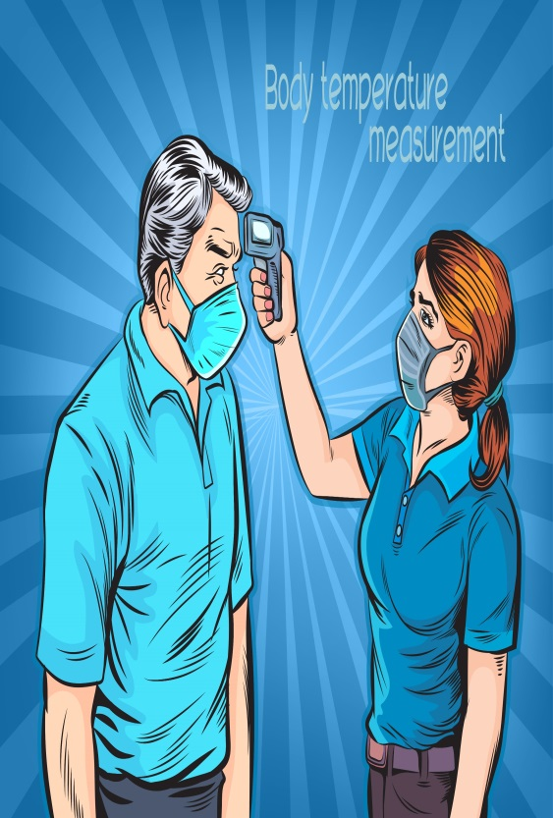
- If someone conducts the screening, make sure the temperature/symptom screener avoids close contact with workers to the extent possible.
- Both screeners and employees should wear face coverings for the screening.

STAY HOME IF SICK
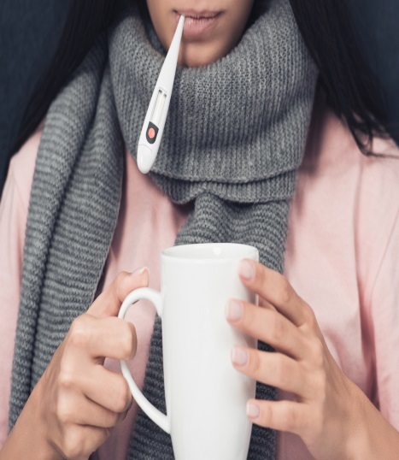
Encourage employees to stay home, call a healthcare provider if they have symptoms.
Employees should NOT come into work if the employee is experiencing
- Frequent cough
- Fever
- Difficulty breathing
- Chills
- Muscle pain
- Headache
- Sore throat
- Recent loss of taste or smell
Or if they or someone they live with have been diagnosed with COVID-19.
WHEN TO SEEK MEDICAL ATTENTION
Seek medical attention if symptoms become severe, including persistent pain or pressure in the chest, confusion, or bluish lips or face.
This list is not all possible symptoms. Please call your medical provider for any other symptoms that are severe or concerning to you.

Call 911 if you have a medical emergency
Notify the operator that you have, or think you might have, COVID-19. If possible, put on a cloth face covering before medical help arrives.
SYMPTOMATIC EMPLOYEES OR CUSTOMERS
If an employee or customer is (or becomes) symptomatic of COVID-19, it is important that they be sent home immediately.
Symptomatic employees should be asked to return home and self-quarantine for 14 days.
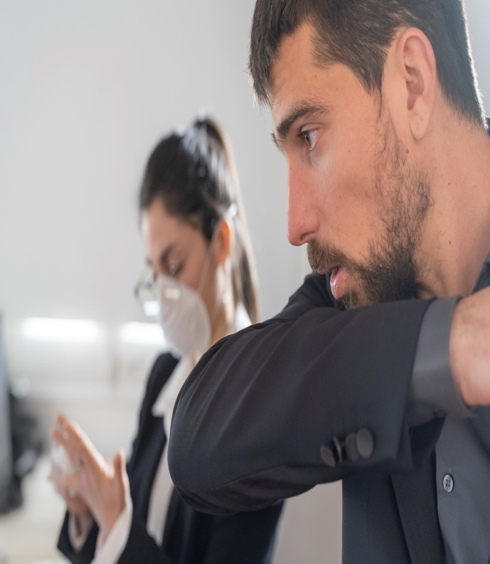
Area(s) where employee worked (e.g., service department) will be closed for deep cleaning and sanitization process will be performed upon confirmation that a person who had COVID-19 symptoms or was infected with COVID-19 was present at the dealership.
RETURNING TO WORK
Employees should contact Human Resources prior to returning to work to advise that they have met one of these criterion for their return, and to discuss documentation that may be required prior to return to company premises.
People with COVID-19 symptoms who have suspected COVID-19 or who have tested positive with COVID-19 can return to work, after confirmation from Human Resources, using one of the following two strategies:
Symptom-based strategy
Persons with COVID-19 who have symptoms and were directed to care for themselves at home may discontinue isolation and return to work when they have met the following criteria:
- Improvement in respiratory symptoms (e.g., cough, shortness of breath), and
- The later of the following:
- At least 10 days have passed since symptoms first appeared; and,
- At least 3 days (72 hours) have passed since recovery defined as resolution of fever without the use of fever-reducing medications.
Test-based strategy
Persons with COVID-19 who have symptoms and were directed to care for themselves at home may discontinue isolation and return to work when they have met the following criteria:
  - Resolution of fever without the use of fever-reducing medications, and
  - Improvement in respiratory symptoms (e.g., cough, shortness of breath), and
  - Negative results of an FDA Emergency Use Authorized COVID-19 molecular assay for detection of SARS-CoV-2 RNA from at least two consecutive respiratory specimens collected at least 24 hours apart (total of two negative specimens)

The symptom-based, time-based, and test-based strategies may result in different timeframes for discontinuation of isolation

Note that recommendations for discontinuing isolation differ between persons who have had symptoms and persons who have not had symptoms of COVID-19
People without COVID-19 symptoms but who have tested positive with COVID-19 can return to work, after confirmation from Human Resources, using one of the following two strategies:
Symptom-based strategy
Persons who have tested positive COVID-19 and who have never had symptoms may return to work when 10 days have passed since the date of their first positive COVID-19 diagnostic test assuming they have not subsequently developed symptoms since their positive test. If they develop symptoms, then the symptom-based or test-based strategy should be used. Note, because symptoms cannot be used to gauge where these individuals are in the course of their illness, it is possible that the duration of viral shedding could be longer or shorter than 10 days after their first positive test.
Test-based strategy
Persons who have tested positive with COVID-19 and who have never had symptoms may discontinue isolation and return to work when they have received negative results of an FDA Emergency Use Authorized COVID-19 molecular assay for detection of SARS-CoV-2 RNA from at least two consecutive respiratory specimens collected at least 24 hours apart (total of two negative specimens).
If you have any symptoms of COVID-19 notify the COVID-19 Team Captain immediately and contact a health care professional for advice.
If any employee has symptoms, disinfecting of work areas should occur immediately.
OUR PLAN SUMMARY
Management and/or a designated member of the company COVID-19 Team is tasked with ensuring that our dealership takes appropriate measures to meet city, state, and federal guidelines
What the Company must do:
- Follow the written plan
- Provide contact info COVID-19 Team and for local health department
- Train and communicate with all current employees and new hires prior to working
- Regularly audit for compliance and correct deficiencies
- Investigate any COVID-19 illness and update plan as needed
- Identify close contacts of an infected employee and isolate
- Adhere to guidelines of company-provided training
ACKNOWLEDGMENT OF RECEIPT OF PLAN AND AGREEMENT TO COMPLY WITH PLAN
This will acknowledge that I have received and reviewed a copy of the Dealership COVID-19 Prevention and Response Plan.
I also acknowledge that I have been instructed to read the Plan and become familiar with its contents.
I further acknowledge and agree that I will comply with the terms of the Plan as a condition of my employment.

Signature |  | Date
Printed Name

Please return the signed acknowledgement to Human Resources

